Chapter 4, Problem 37.

Find the Norton equivalent with respect to terminals a-b in the circuit shown in Fig. 4.104.

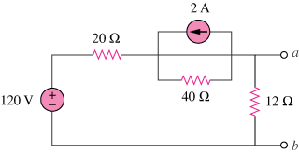

Figure 4.104
For Prob. 4.37.

